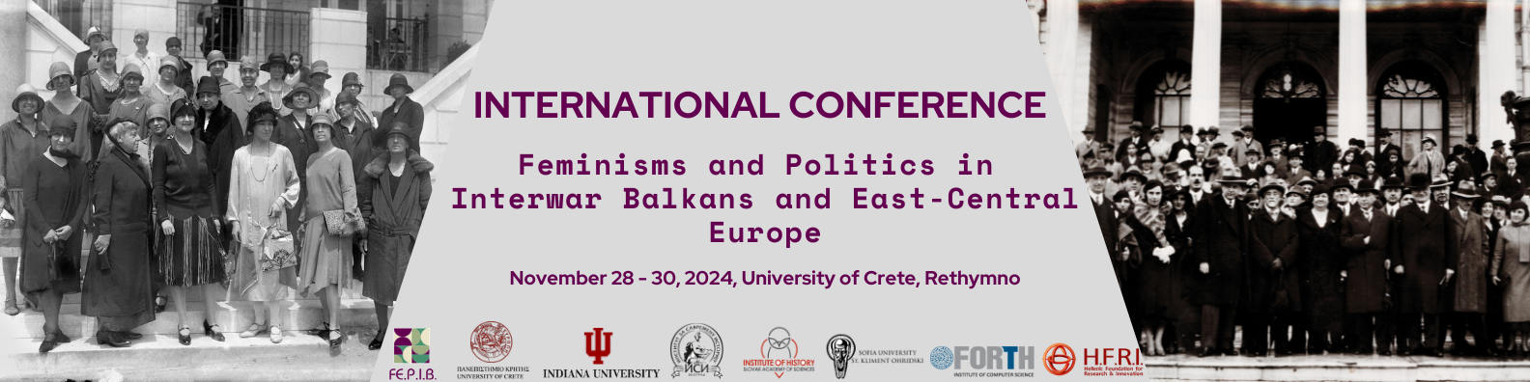

**Individual paper submission form**

|  |  |
| --- | --- |
| **Name(s)** |  |
| **Contact details - Email address** |  |
| **Affiliation** |  |
| **Paper title** |  |
| **Abstract (250 words)** |  |
| **Keywords (up to 5)** |  |
| **Topic addressed** | (Number of the topic on CfP) |
| **Would you be willing to chair a session** | YES/NO |
| **Short bio** |  |

**Please send your abstract as an email attachment, , by ~~June 30, 2024~~ July 31, 2024 to**

[fepib-conference2024@ia.uoc.gr](mailto:fepib-conference2024@ia.uoc.gr)